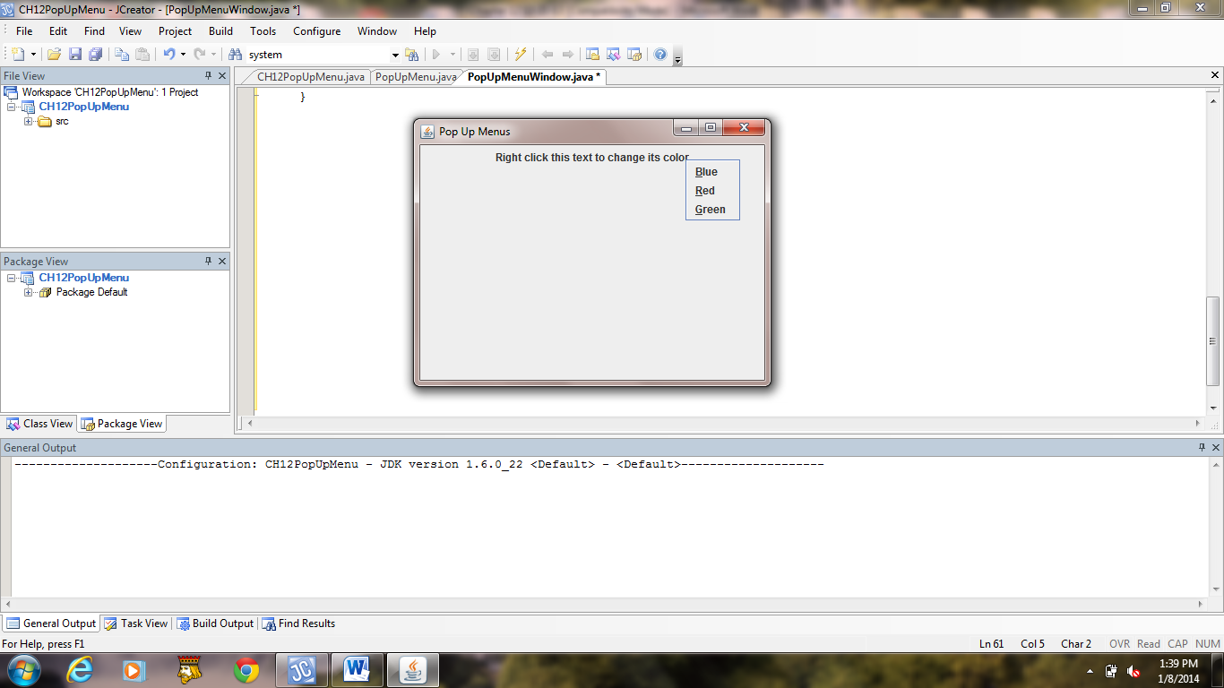 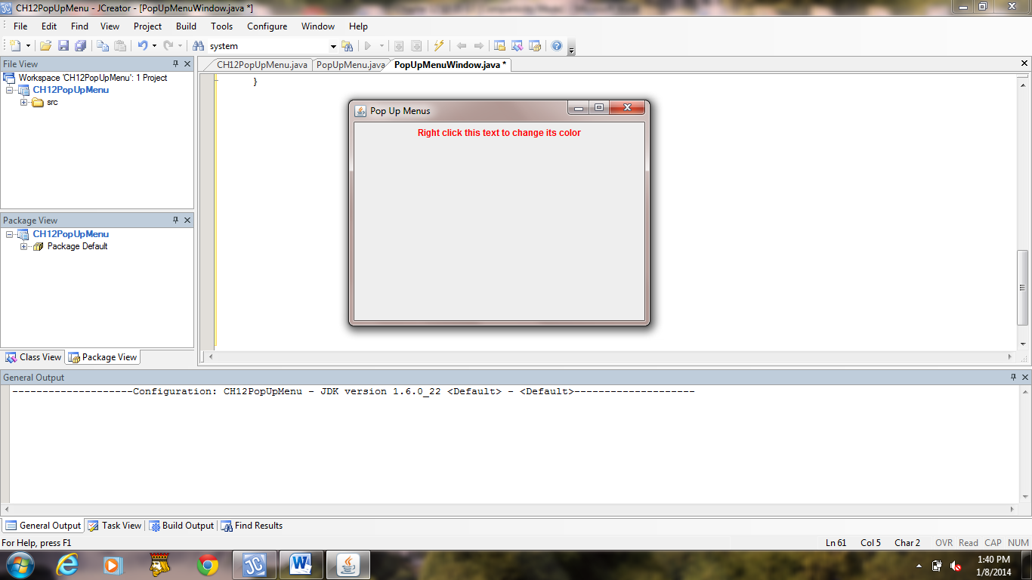

**a) b)**

**Figure 12.18 Windows produced by the application PopUpMenu.**